The Fast Game
A discipleship game designed to help you engage with the world and people around you.

This flexible, radical, non-book, discipleship tool, can be used with non-
Christians through to older believers, but is designed with young people in mind. Using a board game approach with celtic designs, people are less intimidated than when using traditional methods of discipleship and open up at a surprisingly deep level. A modern version of a bible story is told (examples come supplied) and the game helps you share your thoughts, feelings, and engage with the story, then translate this into action during the coming week. Leaders can choose stories tailored to the group and the flexible nature of the game means there is no limit to the amount of times it can be played and could revolutionise the way you approach discipleship.

The game is supplied complete with sample stories, laminated playing surface, dice, cards, natural counters, modelling clay and instructions. £20 plus packing and postage. Order it by emailing me from www.sundaypapers.org.uk

The FaSt Game has been developed as a tool to help people grow and develop in their knowledge of and faith in God. It is primarily aimed at young people who have little or no understanding of Christianity, and who would not feel comfortable with a linear or book orientated discipleship programme. It can be played by any number up to 32 using teams of players but is ideally suited to a group of 6-8 individuals. The name comes from the four main elements of the game: Feelings, Action, Story, Thought.

Not a competitive game; it encourages people to open up their lives, to listen to and draw from other people's experience of life and to impact the world around them. Therefore it is most beneficial when a series
of games are played over a number of weeks rather than as a one-off game. As the game is a discipleship tool it encourages openness and accountability. This is done through the group deciding if the answers given have been open and honest enough for the players to collect their cards. The same accountability applies to the action that is due to be undertaken in the week, as the group ask one another the following week whether they have carried it out or not.

The Feelings cards are designed to explore people's personal feelings and life experiences. The Story cards are to help people interact with the story and learn it and its meaning. The Thought cards help the player talk about people closest to them and the world around them. The Action cards then put into practice what has been learnt throughout the game.

As the game is flexible it is down to the leader to facilitate the group playing the game. They can choose stories right for the group, tell them in their language, and provide the right atmosphere and environment to get the most from the game. The Celtic knot at the centre of the board symbolises the coming together of everyone's story and the elements that make up the game.

Extracted from “YouthWork” magazine
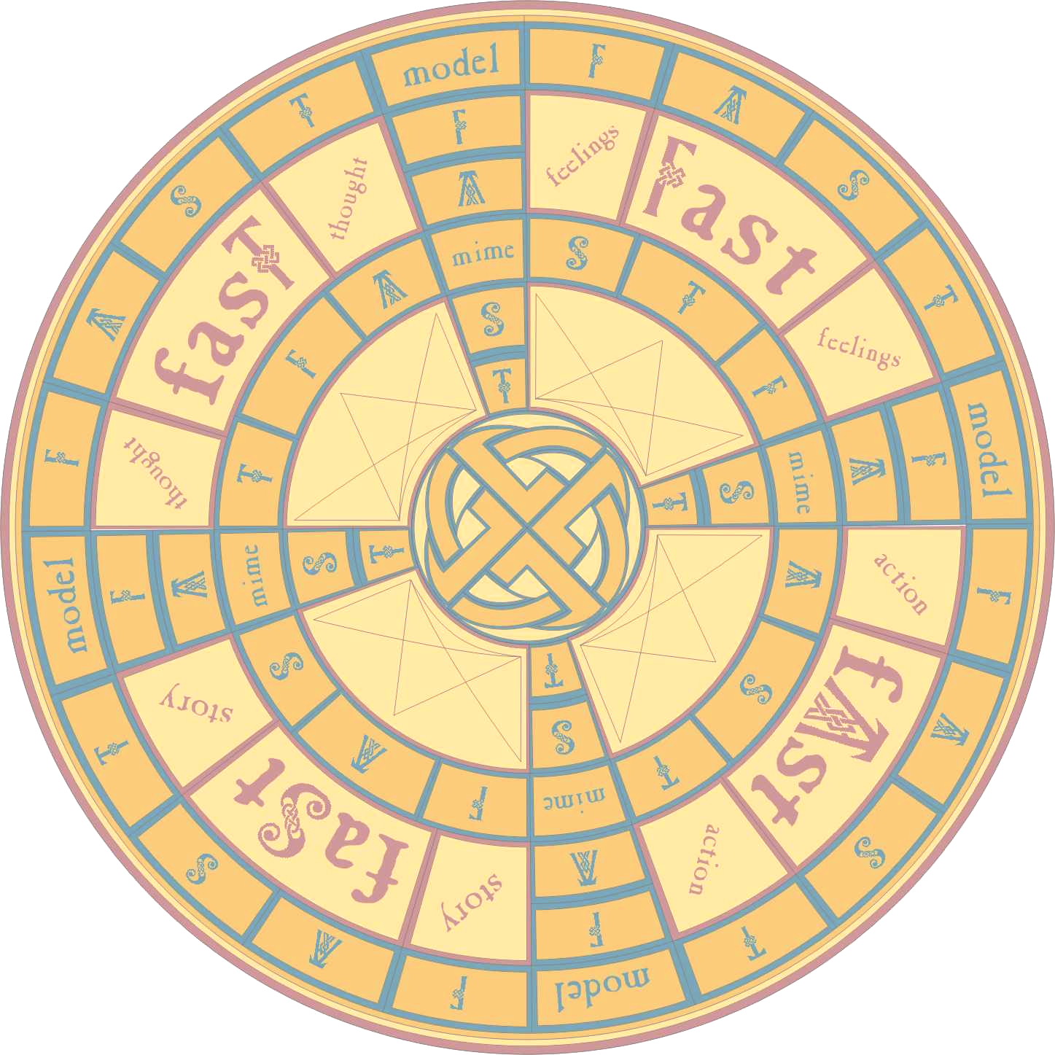

Games:

The Fast Game

By Richard Passmore

Reviewed by Kevin Elliot, a detached volunteer
youthworker in Cheltenham.

When a genuine resource aimed at use with the non-book culture comes along, you have to take it seriously. The experience of the games creator, is predominately that of detached work in “needy areas” while also being strongly influenced by the ways of the Celtic Christians.

The Celtic influence comes in the design and lettering of the roll up board/mat, and the “natural” counters i.e. small stones and shells. It is designed such that it can be played with your pregnant teen excluded pupil and her joy-riding brother, and can be used for small or large numbers.

The game can actually be quite fast, five of us did it sub-hour, and while supposed to be non-competitive, the winner enjoyed being first! The game hinges on a story you chose ideally a parable retold in a modern setting. While Richard gives out some ideas, only one example is written out in full – that of the Prodigal Surfer who converts half his Dad’s luxury hotel into holiday flats flogs them and sets off. So after your first go there is an amount o pre-work needed, which some will love doing but others will struggle with.

I think a dozen good examples would have made all the difference. You have to collect four cards (one for each letter) and return home to win. Your “F” and “T” cards makes you share a “Feeling” or a “Thought” about yourself but in some way mirrors or relates to something from the story. The “S” card gets you to retell the Story in your own words, while the “A” commits you to doing some relevant “Action” in the following week (but not running off with half your Dads money!).

Other squares give you the chance to mime or use modelling clay. There is even a non-compulsory egg-time to hurry the hesitant.

It’s original, it’s fun and it works well with all types, if you can handle the players with the right mix of sensitivity and persuasion. More importantly it is possibly the only Christian game that some “street kids” could benefits from.

