Why Sunday Papers?

The title comes from thoughts about what church in a post Christian society should look and feel like. It takes the notion that church should be more like sitting around with your friends on holiday and reading the papers. You know that time when things are chilled, maybe you rented a house, maybe you’re sitting at home, or in a tent. You’re sharing the Sunday papers out amongst each other, Mum has the Mail, your mate has brought the Times, and you and everyone else are nicking bits off each of them and the kids are arguing about who reads the funnies first. You drift in and out of conversation, as different articles, adverts and bits catch peoples’ attention. There’s big pot of coffee on the go, everyone has a different opinion, and even though you can’t believe Mum still reads the Mail, and discussions get heated from time to time, the relaxed supportive environment, mirrored by the smell of the coffee pervades all.

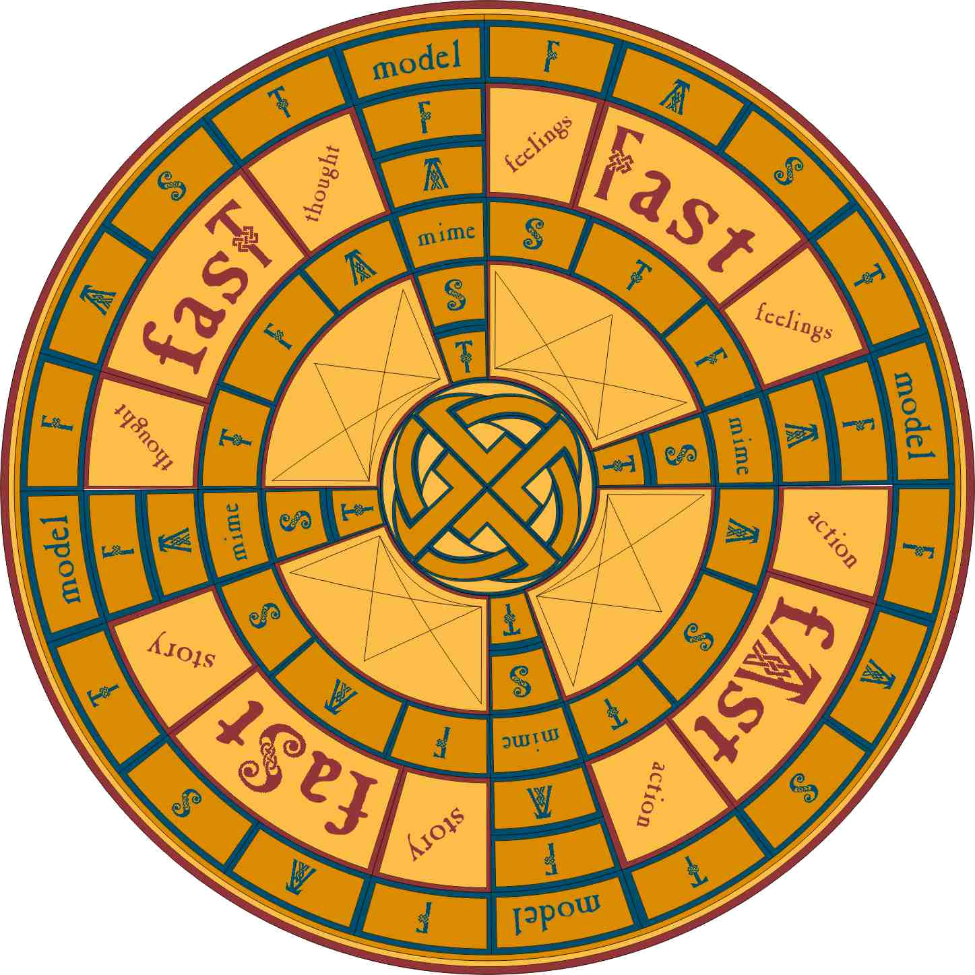
We need a paradigm shift in how we do church? Our thoughts and approaches to church are at best out dated and for the vast majority of people irrelevant. If we are going to connect in a meaningful way with those and the world around us we need to radically rework what we mean by church. The paradigm shift (right) image I find helpful as it demonstrates the scope of the change needed, but takes into account that we cannot be the new creation without the old that nurtured us. As a missionary focussed youth and community worker much of my work has been about growing church with young people that carry a resonance between the two paradigms but can clearly exist within the new. The Fast Game was such an expression – Church as a board game. Check out the links under Youth Work Tacks for more information.

Sunday Papers contains the Blog in the centre, which is a collection of thoughts, events, a kind of online journal. Down the right hand are a series of links:

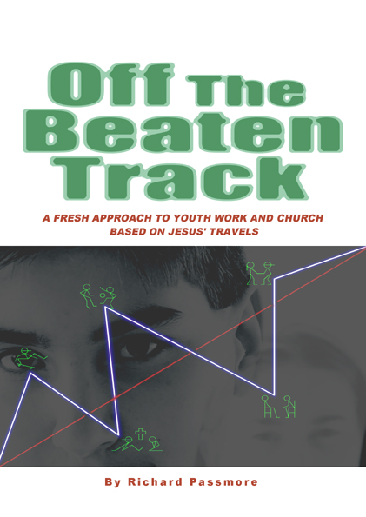
My Links: The Gallery has images that may be of use to provoke discussion, as well as general photos. The other items also include links to the two books I have written that expand many of the concepts touched on by Sunday Papers.
Other Blogs: Links mainly to other people bloging about emerging church and mission.
Articles: Mainly stuff we have written but also with some links to other good related articles around
Youth Work Tacks: Ideas and resources for working with young people mainly when trying to do youth work INFRONT of church rather than OUT FROM church.
Talks and Presentations: Pretty self explanatory.
So finally who am I? Well there is a bit in the profile on the site, but I thought I would borrow a bit from Off the Beaten Track as I think it paints more of picture of who I am, where I am going from, and how this shapes Sunday Papers.


“In order to look ahead and plan a new adventure it would be irresponsible not to do some looking back but only in order to learn not to hold us back. One thing I have come to realise as I look back over my life is that I have been called a lot of things, as a child I was a right pain driving my brother and sister to bury me in the sand and call me a host of names. More recently I have been described as a detached worker, evangelist, Christi-anarchist, team leader, missionary, and pain in the arse, amongst others. I like being hard to label, but as I reflect on why this is the case I hope it is because of how I think about the message I carry. I believe the gospel to be an expansive thing that cannot be pinned down and that has change and restoration at its heart. Change from injustice and oppression to justice and freedom, a restoration of relations at all levels including between God and Humanity, between people, between the person and themselves, and between Humanity and Creation. All of this is the heart of the gospel and to take any one part and place it above another is undermining the very essence of the message that Christ came to bring. Grouping these concepts is often described as Kingdom theology because it is not just about the individual or a single theological strand but relates to Jesus’ challenge of the kingdom of God that desires change. As Jim Wallis the founder of Sojourners puts it “To be an active agent of the kingdom is our highest calling. The kingdom generates new forces of righteousness, justice and peace through the means of servanthood and self giving love….we begin to test things by a biblical judgement and the church is slowly led from conformity to community and change…..The kingdom is within us and among us; it is our standard, our calling, our hope and our salvation. It is deeper, stronger, more profound and lasting than all our programmes, strategies, projects and causes.”

Be Still and Still Moving

There are many other writers and theologians who expound on kingdom theology Jim Punton whose writings can be found on the FYT website www.fyt.org.uk and Donald Kraybill “The upside down kingdom” are good places to start.

